Alarm: ID 01: E-Stop Button Active
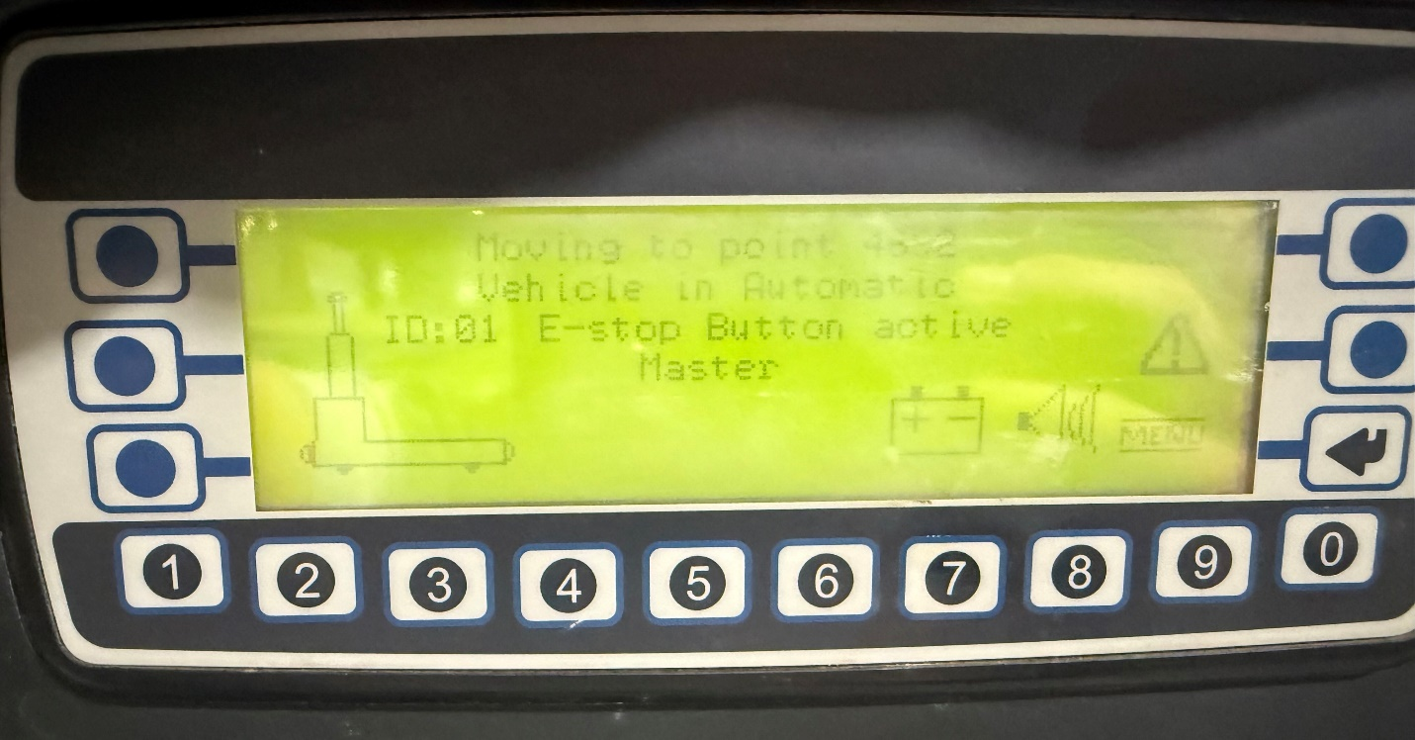
How To Fix:
- Check both E-stop buttons on the AGV. They are located on the left and right sides.
- On newer AGVs, the buttons will be red twist-style E-stops.
- On older AGVs, the buttons will be black push-in style on each side.
- Ensure both buttons are disengaged to allow normal operation.

